**Loftus Perennial Flowers**

**Erigeron karvinskianus** Common name: **Mexican Fleabane**

**Location:**

Loftus square, walls surrounding Sand Park.

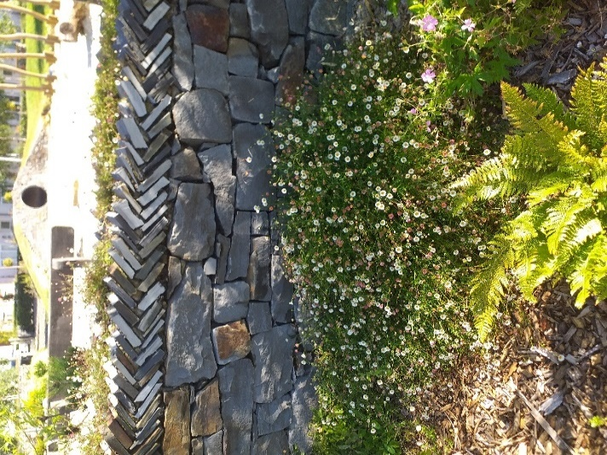

**Description:**

This colourful perennial is part of the Asteraceae family (commonly known as the daisy family). It is perfect if you are looking to fill up some empty space in your garden as it spreads far and wide, it can also grow to a height of nearly 6 inches. They are well suited for various types of garden areas such as Coastal gardens, rockeries, cottage gardens, gravel gardens and garden edging. There is no need to deadhead these beautiful flowers, but you may cut back new shoots close to ground level early in the spring if you wish.

**Soil type/ PH:**

This daisy would rather be exposed to full sunlight although it can deal with partial shade. Soil must be well drained, and it will deal with both acidic and alkaline soil, making it quite neutral. Extra care must be taken in the summer to ensure it doesn’t dry out.

**Aspect:**

These perennials love to be fully exposed to sunlight and can be either west, south or east facing. It is also drought tolerant.

**Wildlife Value:**

This deciduous plant is rich in pollen and nectar making it perfect for attracting bees and other pollinators. It does well to accommodate butterflies, moths and many beneficial insects.

**Pests and Diseases:**

Generally, this plant is pest and disease free.

**Interesting Fact:**

Its common name the ‘Mexican fleabane’ comes from an age-old superstition stating that a dried Erigeron Karvinskianus is a repellent for fleas. I wouldn’t let your dog near it though, as it can be toxic for your household friends if digested.